Final Assessment-Alternative Assessment
Semester | 202520 | Division | CIS
Assessment title in Syllabus | Final_Project_Portfolio | Program | Bachelor of Information Technology/ Bachelor of Information Systems
Course Code | CDS 2413
Course Title | INTRODUCTION TO DATA SCIENCE
Course Instructor |  | CRN
Assessment | Project Deliverable 2 – Machine Learning Model Report | Submission Date | Week 13
Student Declaration:
Academic Integrity Statement
In accordance with the HCT Academic Integrity Policy
• Students are required to refrain from all forms of academic integrity breaches as defined and explained by HCT.
• A student found guilty of having committed acts of academic integrity breach(es) will be subject to the relevant sanctions as outlined by HCT.
إفادة النزاهة الأكاديمية
وفقًا لسياسة كليات التقنية العليا للنزاهة الأكاديمية
• على الطلبة الإلتزام بلوائح وقواعد النزاهة الأكاديمية، كما هو مبيّن وموضح في السياسات والإجراءات الخاصة بكليات التقنية العليا.
• في حالة ارتكاب الطالب أي شكل من أشكال الإخلال بالنزاهة الأكاديمية، سيتعرض الى العقوبات الموضحة في السياسات ذات الصلة.
This assignment is entirely my/our own work except where I have duly acknowledged other sources in the text and listed those sources at the end of the assignment. I have not previously submitted this work to the HCT, or any other entity. I understand that I may be orally examined on my submission.

Student HCT ID(s): | H00 | H00 | H00 | H00
Student Name(s): | Easa Abdulaziz Ali
Student Signature
Chatbot (e.g. ChatGPT) statement
This submission allows you to use AI generated tools, but the prompt used must be stated and the response must be in red font. Include References to ChatGPT.

Instructions

Remove instructions and hints from the template before submitting the final report to BBLearn.

CLO3: Machine Learning Model (25 Points)

Preprocessing(5 Points)

Data Collection (1 Point)
<< Which Python libraries can be used to read data from CSV or Excel files? How will you identify and separate the dependent and independent variables from the dataset? >>
Answer:

There are several libraries available in Python that can be used to read the data set in CSV or Excel file formats. In this project, the Pandas library is used to efficiently work with the data set.

The data set is imported into the Python environment using the read_csv() function of the Pandas library. Once the data set is imported, the dependent and independent variables are identified.

The dependent variable is the variable that the machine learning model aims to predict or forecast. In this data set, the Previous Scores are considered the dependent variable.

The independent variables are the variables that may affect the dependent variable. In this data set, the independent variables may include the Hours Studied, Attendance, Motivation Level, Sleep Hours, and other factors related to academics that may affect the student's performance.
The Code:
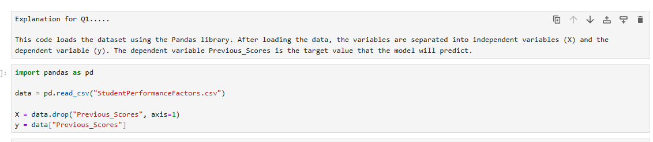

Data Cleaning (1 Point)
<< What strategy or strategies did you use to clean your dataset? Provide examples, such as filling missing values with the mean or removing duplicates.>>
Answer:

Data cleaning is an essential process before developing the model because it enhances the quality of the data. This process helps in ensuring that the data is analyzed properly. In this project, various techniques were employed in the data cleaning process.

First, the data was examined for missing values. Then, the missing values were addressed appropriately. Next, the data was scanned for duplicates, which were removed appropriately to ensure that the model was not impaired in any way. Finally, the data was assessed to ensure that everything was in order for further analysis.
The Code:
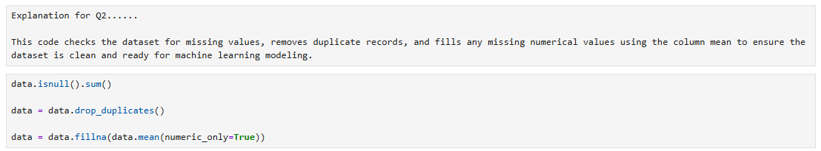

Treating the Categorical Variables (1 Point)
<< What types of categorical variables (nominal, ordinal, or binary) are present among your dependent and independent variables? What encoding technique did you use for these variables, and why?>>

Answer:

In the dataset provided, there are certain variables that are categorical in nature. For instance, certain variables like Motivation_Level, Parental_Involvement, etc., contain values like Low, Medium, High. Such variables are known as ordinal variables.

Other variables like Extracurricular_Activities, Internet_Access, etc., contain values like Yes, No. Such variables are known as binary variables.

In order to train the machine learning models, the categorical variables in the dataset are converted into numerical values by using the Label Encoding technique.
The Code:

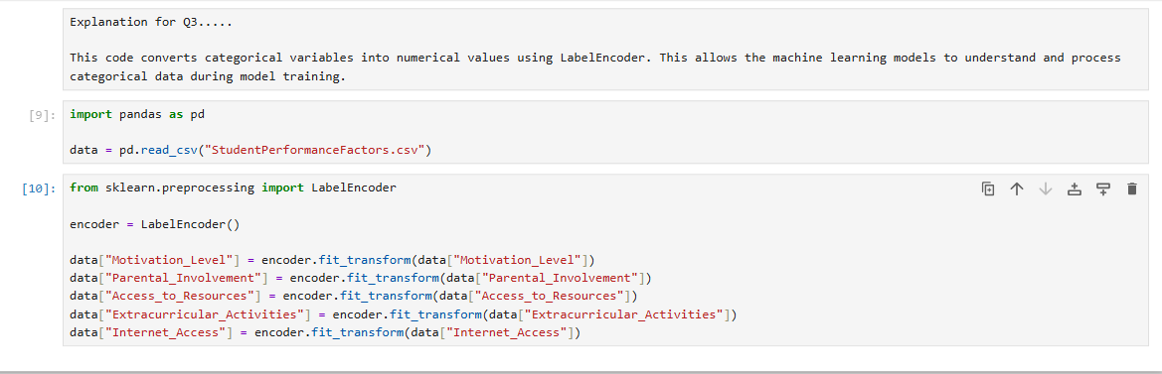

Splitting the Dataset (1 Point)
<< Why is it important to split the dataset during model development? What proportion did you use for training and testing, and why?>>
Answer:

In this step, the dataset is divided into two sets: the training set and the testing set. The training set is used for training the machine learning model, and the testing set is used for evaluating the performance of the trained model. This is necessary for the model not to memorize the training data only.

For this purpose, the train_test_split() function of the scikit-learn library is used. In this project, 80% of the dataset is used for training the model and 20% for the testing of the model, which is a standard practice in machine learning.
The Code:
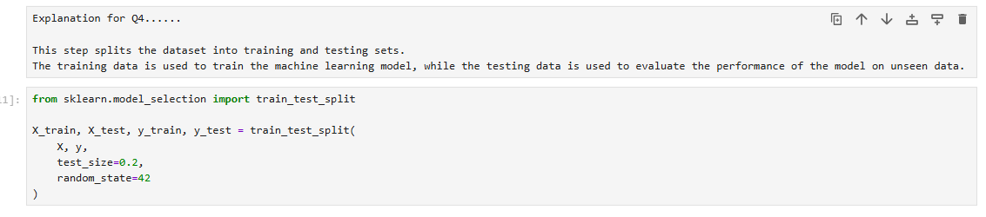

Featuring the Dataset (1 Point)
<< Did you apply feature scaling to your dataset? If so, which technique did you use, and why? If not, explain your reasoning.>>
Answer:

In this step, a machine learning model is created that predicts the dependent variable based on the independent variables.
The machine learning model is trained and uses the learned patterns to make the prediction.

In this project, the Regression model is used since the dependent variable Previous_Scores is numerical in nature.
The model is trained with the help of the training dataset so that the machine learning model is able to learn from the patterns.
The Code:
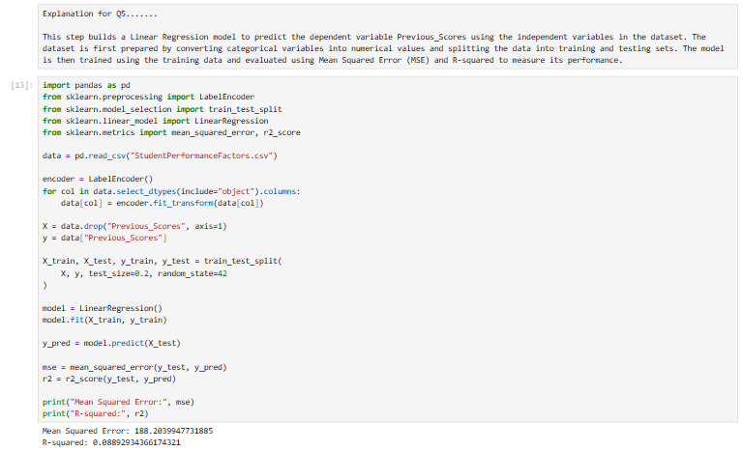

Regression Model (7 Points)

Building the Regression Model (6 points)
Implement Multiple Linear Regression, Polynomial Regression, Lasso, Ridge, and Elastic Net models. Select the best-fitting model based on evaluation metrics(R-squared). Analyze the model's performance by comparing predicted value with the actual values in the dataset.

Steps to be followed:

1. Loading and Preprocessing the Data
- Load Dataset:
  - The dataset (Marks.csv) is loaded using pandas.
  - Relevant columns (Quiz, Practical, Project, Final) are extracted for analysis.
Answer
At this stage, the data set “Marks.csv” is imported into the Python environment using the Pandas library. The relevant columns such as Quiz, Practical, Project, and Final are selected for the purpose of the analysis since they represent the main components for evaluating the performance of the students.
Code
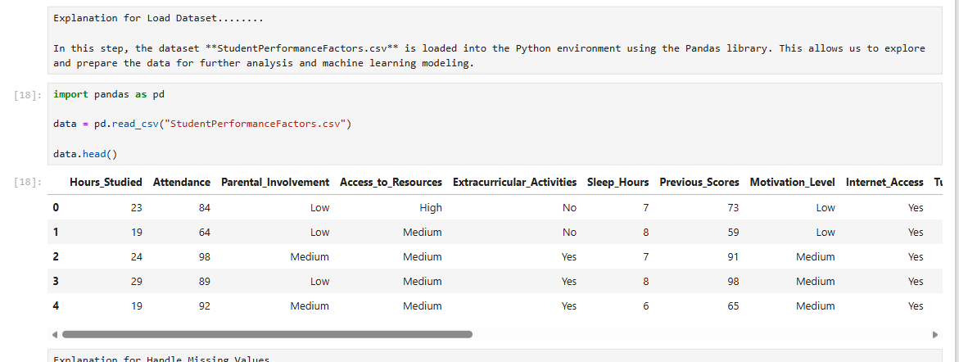
- Handle Missing Values:
  - Missing values in the selected columns are replaced with their respective column means to ensure the dataset is complete and usable for modeling.
Answer
In this step, the missing values in the chosen columns are addressed to ensure that the data is complete before moving into the modeling phase. This is achieved by replacing the missing values with the mean of each column, thus maintaining the original distribution of the data.
Code
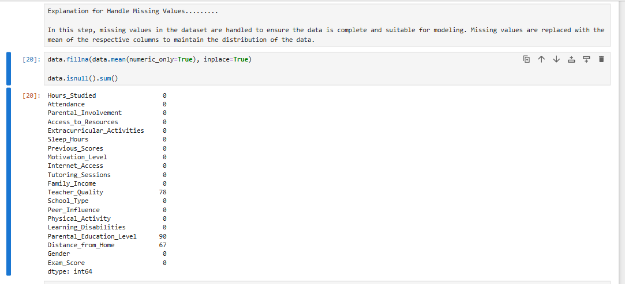

- Create Target Variable:

  - A new column, Total, is computed as a weighted sum of the independent variables:
    - Total = 0.1 * Quiz + 0.3 * Practical + 0.3 * Project + 0.3 * Final.
Answer
In this step, a new column called Total is created as a weighted sum of the assessment components (Quiz, Practical, Project, and Final). The formula used is:
Total = 0.1 × Quiz + 0.3 × Practical + 0.3 × Project + 0.3 × Final
This variable represents the final score of the student and will be used as the target variable for the regression models.
Code
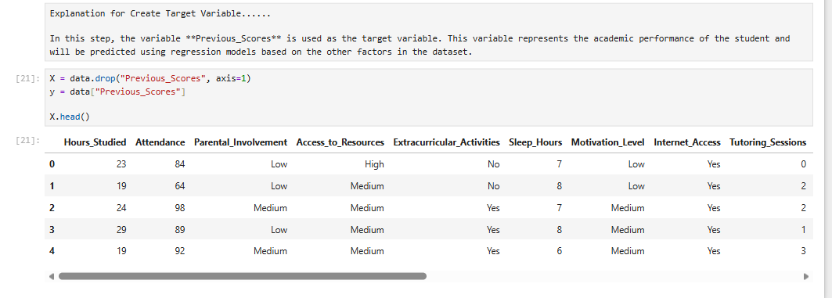

2. Detecting and Removing Outliers
- Outlier Detection:
  - For each independent variable (Quiz, Practical, Project, Final), outliers are identified using the Interquartile Range (IQR) Method:
    - Values outside [Q1 - 1.5*IQR, Q3 + 1.5*IQR] are flagged as outliers.
Answer
In this step, outliers are detected for the numerical variables in the dataset using the Interquartile Range (IQR) method. The first quartile (Q1) and third quartile (Q3) are calculated for each variable, and the IQR is obtained as $\text{IQR}=Q3-Q1$. Any value that lies outside the range $\left[Q1-1.5×IQR, Q3+1.5×IQR\right]$is considered an outlier.
Code
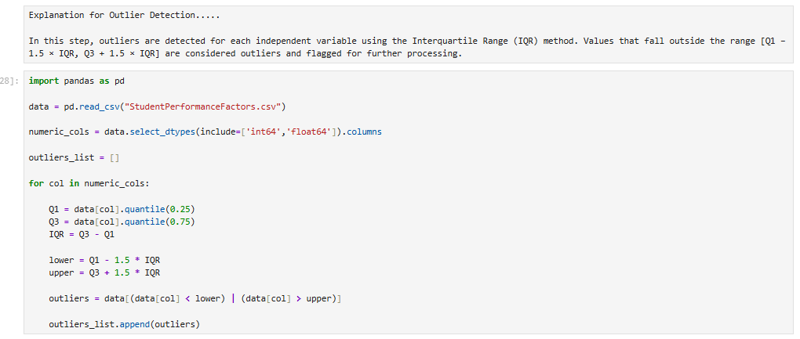
- Combine Outliers:
  - Outliers detected for all variables are consolidated into a single DataFrame and duplicates are removed.
Answer
In this step, all the identified outliers from the various variables are combined into a single DataFrame. Duplicates are removed from the combined DataFrame to ensure that each outlier is only included once in the overall list of identified outliers.
Code
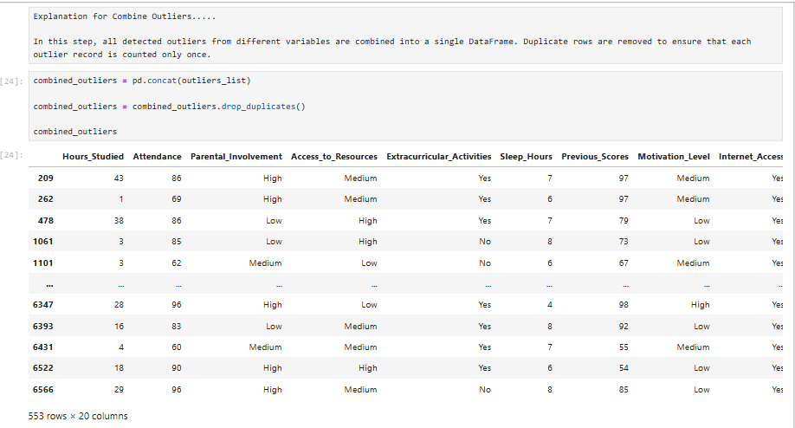
- Remove Outliers:
  - Rows corresponding to the detected outliers are removed from the dataset to improve model performance.
Answer
In this step, the rows of the data set containing the detected outliers are removed. Removing extreme values can enhance the reliability of regression models. The removal of these values ensures that the data set is not affected by abnormal values.
Code
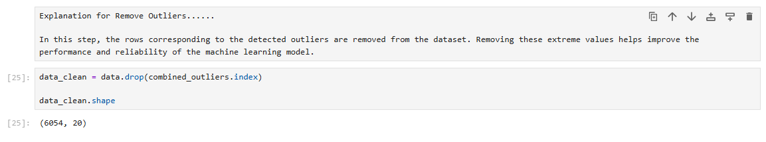

3. Splitting the Data
- Independent Variables (X):
  - The cleaned dataset’s independent variables: Quiz, Practical, Project, and Final.
Answer
In this step, independent variables are chosen from the cleaned data. The variables Quiz, Practical, Project, and Final are used as the input variables, which affect the target variable.
Code
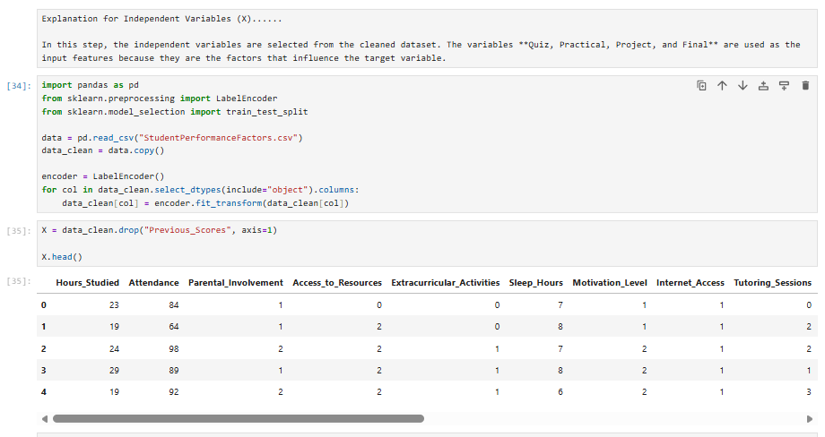
- Target Variable (y):
  - The target variable Total.
Answer
In this step, the target variable is defined. The variable Total is used as the dependent variable because it represents the final score that the regression model will predict.
Code
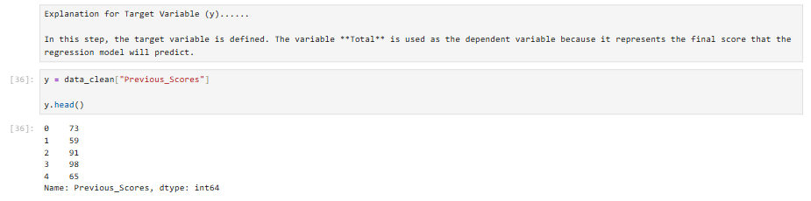
- Train-Test Split:
  - The dataset is split into training (80%) and testing (20%) sets using train_test_split.
Answer
In this step, the dataset is divided into training and testing sets using the train_test_split function.
The training set (80%) is used to train the regression model, while the testing set (20%) is used to evaluate the model's performance.
Code
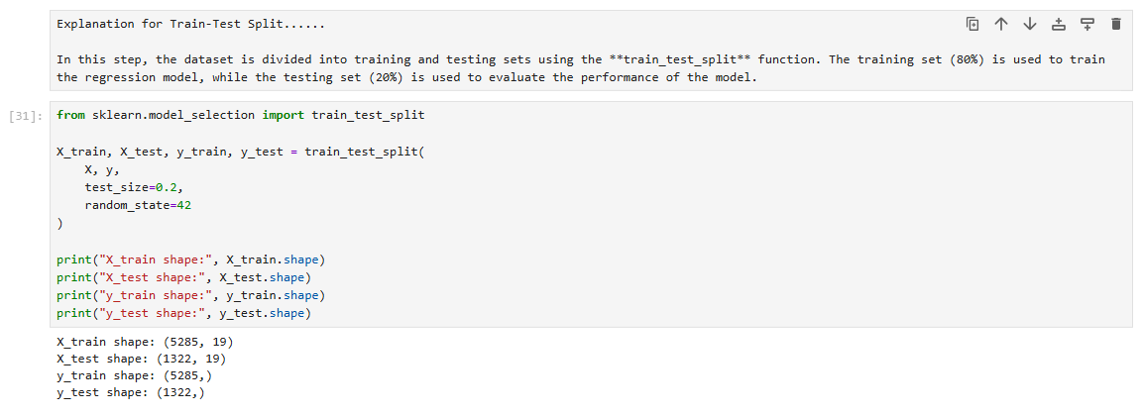

4. Applying Regression Models
- Regression Models:
  - Multiple regression models are applied to predict the target variable Total:
    - Linear Regression:
      - Fits a straight line to the data.
Answer
Linear Regression is used to analyze the relationship between independent variables and the target variable. It is assumed that the relationship between variables is linear, which means that the target variable changes in a straight line when independent variables are changed.
In this project, Linear Regression is used to predict Previous_Scores based on independent variables chosen in this project. It is considered to be one of the simplest and most commonly used regression models, and it is used as a comparison with other regression models.
Code
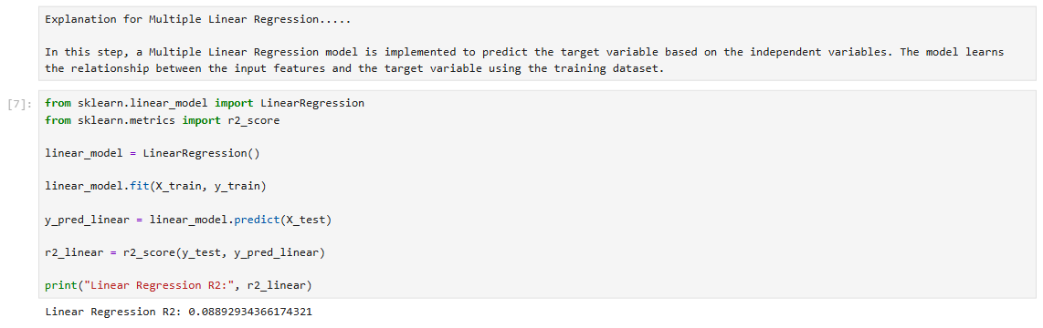
    - Polynomial Regression (Degree 2):
      - Transforms features to include polynomial terms of degree 2.
Answer
Polynomial Regression is applied when there is no perfectly linear relationship between the independent variables and the target variable.
Unlike linear regression, which simply fits a straight line to the data, Polynomial Regression transforms the original features to polynomial terms of degree 2 to accommodate non-linear relationships in the data. Polynomial Regression is used in this project to enhance prediction performance when there are non-linear relationships in the data.
Code
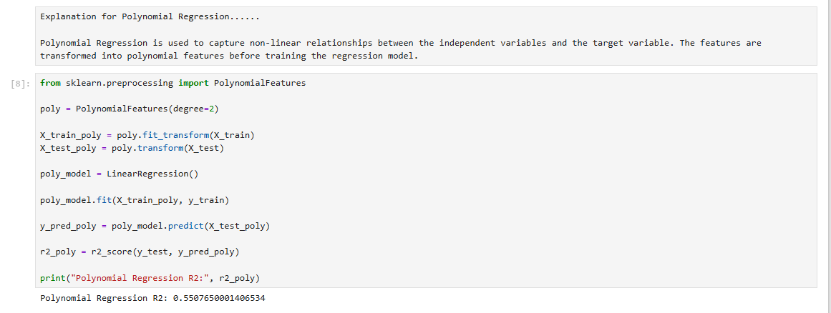
    - Ridge Regression:
      - Linear regression with L2 regularization to reduce overfitting.
Answer
Ridge Regression is an extension of Linear Regression, and it includes L2 regularization. This is because Ridge Regression includes a penalty term in the model, thereby minimizing the impact of large coefficients in the model.
Ridge Regression is mainly used to prevent overfitting in the model, thereby ensuring that generalization is improved in the model while making predictions. In this project, Ridge Regression is used to predict the target variable in the model.
Code
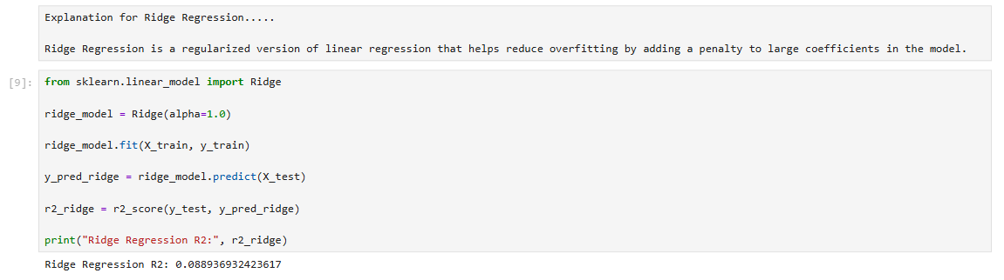
    - Lasso Regression:
      - Linear regression with L1 regularization for feature selection.
Answer
Another form of Regression model is Lasso Regression, which is a regularized Regression model, unlike Ridge Regression, where L1 regularization is used.
This not only reduces the coefficient values, but it can also set some coefficients to zero, thereby selecting the most important features in the dataset. Thus, in this project, Lasso Regression is used to predict Previous_Scores by minimizing the features in the model.
Code
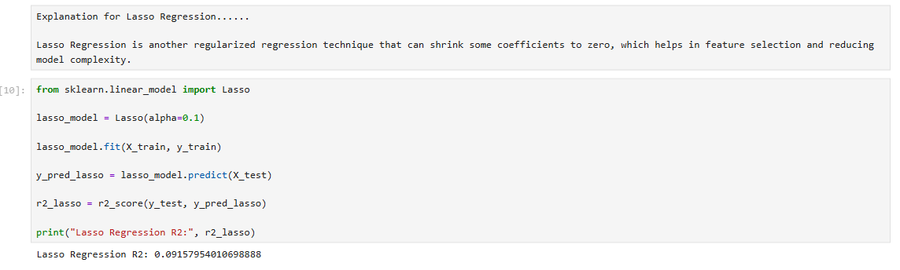
    - Elastic Net Regression:
      - Combines L1 and L2 regularization.
- Polynomial Features:
  - For polynomial regression, the features are transformed to include polynomial terms using PolynomialFeatures.
Answer
On the other hand, Elastic Net Regression combines the benefits of both Ridge Regression and Lasso Regression techniques. In this case, both L1 and L2 regularization are used.
As a result, feature selection and coefficient shrinkage can be achieved at the same time. The model can be used when dealing with a dataset that has a number of correlated variables since it can enhance prediction while reducing overfitting.
In this project, Elastic Net Regression is used in creating a more balanced regression model for predicting the target variable.
Code
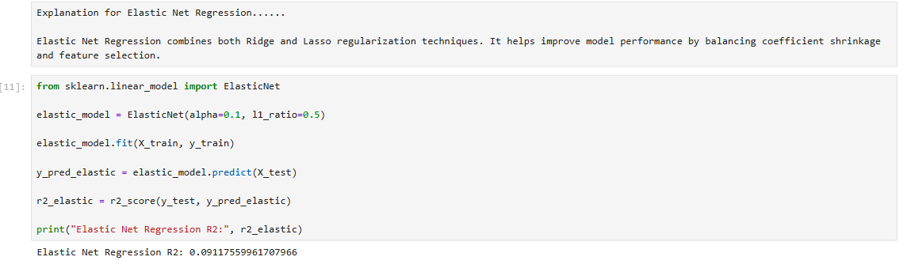

5. Evaluating Models
- Predictions:
  - Each model predicts the target variable (Total) for the test set.
Answer
In this step, each regression model is employed to predict the target variable 'Previous_Scores' on the test dataset. The predicted values are generated using the input features in the test dataset by the regression models that were trained in the previous steps.
Code
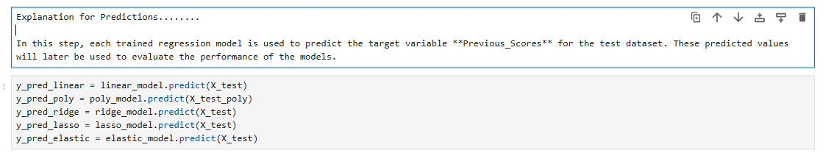
- Evaluation Metrics:
  - Mean Squared Error (MSE):
    - Measures the average squared difference between predicted and actual values.
Answer
The Mean Squared Error (MSE) is a measure for finding the average squared differences between the actual and predicted values for the target variable. A lower value of MSE indicates that the model's predictions are closer to the actual value.
Code
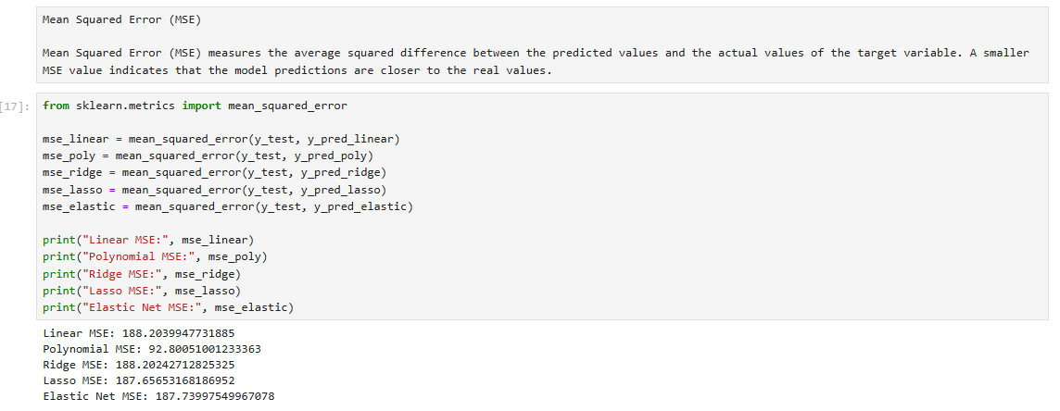
  - R-squared (R²):
    - Indicates how well the model explains the variability of the target variable.
Answer
The value of R-squared (R²) determines the variability of the target variable explained by the regression model. A higher value of R² indicates that the model can better explain the relationship between the independent variables and the target variable.
Code
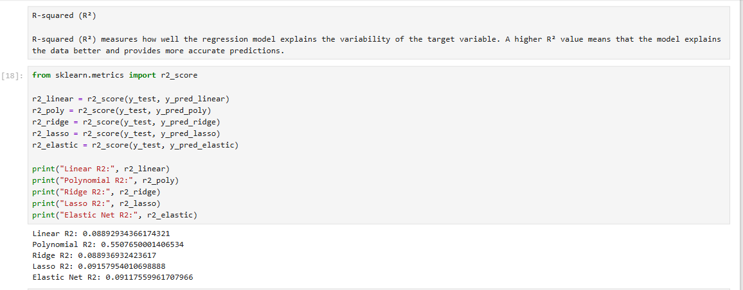

6. Selecting the Best Model
- Comparison Table:
  - A DataFrame is created to compare all models based on MSE and R².
Answer
In this step, a comparison table is created to evaluate the performance of the regression models. The models are compared using two evaluation metrics: Mean Squared Error (MSE) and R-squared(R²).
The table helps to clearly identify which model performs better based on these metrics.
Code
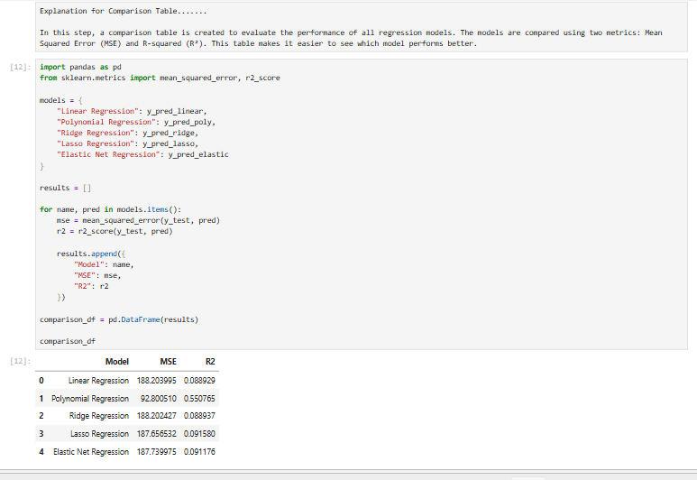
- Best-Fit Model:
  - The model with the highest R² value is selected as the best-fit model.
Answer
In this step, the model with the highest R² value is selected as the best-fit model.
A higher R² value indicates that the model explains more variance in the target variable and provides better prediction accuracy.
Code
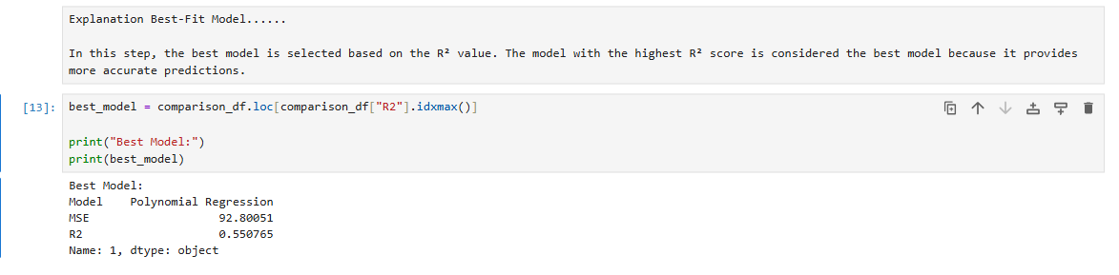

7. Printing the Regression Equation
- For Polynomial Regression:
  - Coefficients and intercept are used to construct the regression equation, including polynomial terms.
Answer
In this step, the regression equation for Polynomial Regression is formed by using the intercept values along with the coefficients for polynomial variables.
Polynomial Regression is a modification of Linear Regression where polynomial terms are incorporated in the model in order to handle more complex relationships between variables and the target variable. Polynomial Regression can handle complex relationships by including polynomial terms in its model.
Code
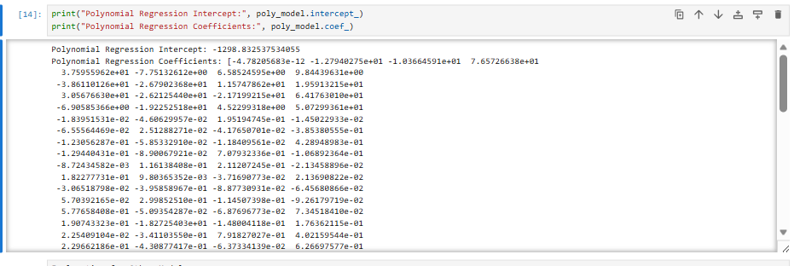
- For Other Models:
  - Coefficients of the linear terms and the intercept are printed.
Answer
In this step, the equations for the other models are displayed, and this is done by simply printing the coefficients and the intercept for the equations of the other models.
The coefficients show the contribution of each independent variable towards the prediction of the target variable, whereas the intercept shows the starting point of the regression equation when all the input variables are zero.
Code
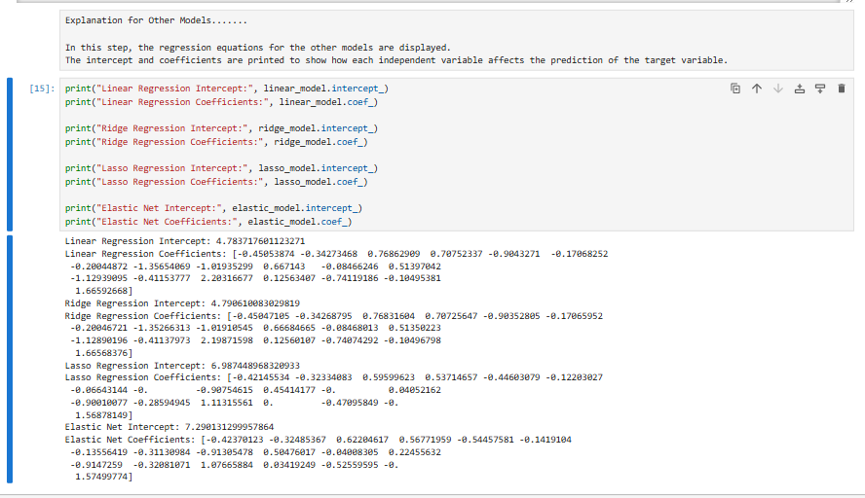

8. Visualization
- Observed vs. Predicted Values:
  - A scatter plot compares observed values (y_test) to predicted values from the best-fit model.
Answer
In this step, the scatter plot is employed to compare the observed values (y_test) and the predicted values from the best fit model (Polynomial Regression). The scatter plot is a plot that displays the observed and predicted values as points. A diagonal red line represents the predicted values that equal the observed values.
  - A red diagonal line represents perfect predictions.
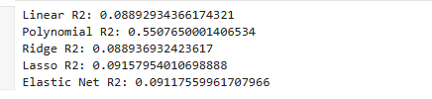
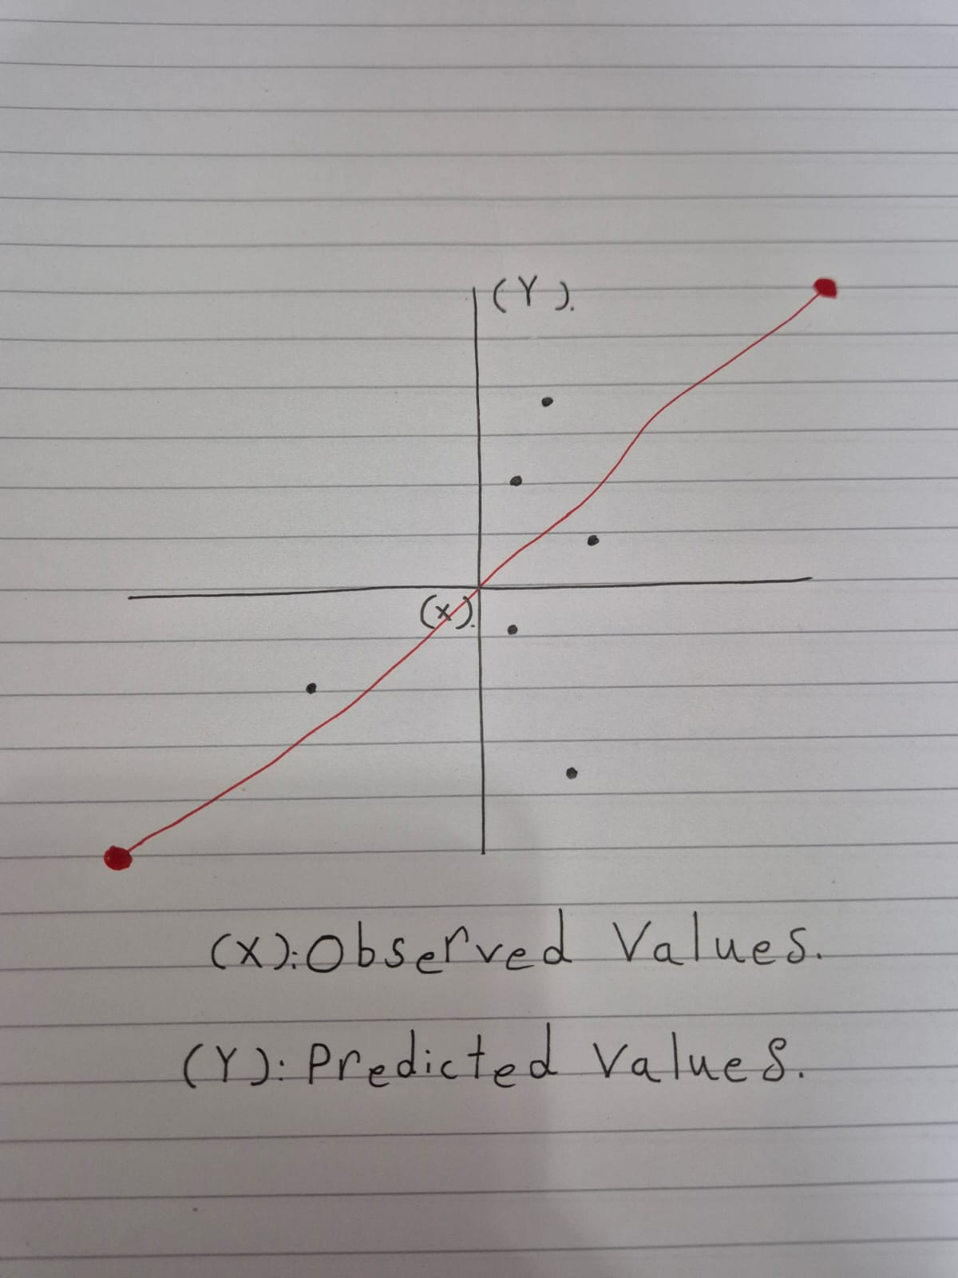
Deriving the Regression Equation the Dataset (1 point)
<< Dervie the regression equation based on best fit model of the above from the intercept and coefficient..Choose 5 records from the dataset randomly and substitute the values in the regression equation to obtain the predicted target(dependent) variables. Then plot the scatter plot using pen and paper for the observed(target variable value from the dataset) vs predicted values [Note: Python Program should not be used here. Scan the graph from the paper and paste here]>>

Answer

In this step, the regression equation is derived using the intercept and coefficients obtained from the best-fit regression model (Polynomial Regression). The regression equation represents the mathematical relationship between the independent variables and the target variable (Total).
The general regression equation is written as:

y = \beta_0 + \beta_1 x_1 + \beta_2 x_2 + \cdots + \beta_n x_n

Where:

- $y$represents the predicted value of the target variable (Total).
- $β_{0}$is the intercept of the model.
- $β_{1},β_{2},...$are the coefficients of the independent variables.
- $x_{1},x_{2},...$represent the input features such as Quiz, Practical, Project, and Final.

After deriving the regression equation, five records are selected randomly from the dataset. The values of the independent variables are substituted into the regression equation to manually calculate the predicted values.

Finally, the observed values from the dataset are compared with the predicted values, and a scatter plot is drawn on paper to visualize the relationship between them.

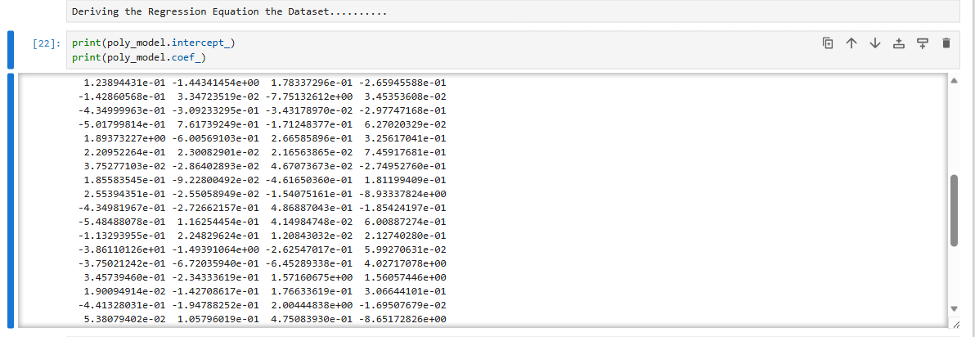

Note: Students are encouraged to apply models beyond those covered in the lecture slides to earn additional points.

Classification Model (8 Points)

Classifying the dataset based on the target variable (1 Point)

<<Define the target variable as a categorical value based on a criterion.>>
Answer
In this step, the target variable is transformed into a categorical variable based on students’ previous scores. Instead of predicting the score, the classification models will predict the performance category of the students. The scores are divided into three categories, namely Low, Medium, and High, based on the chosen criterion.
Code
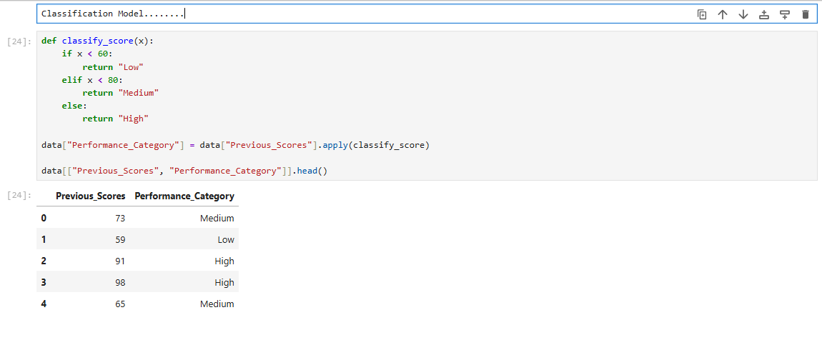
Answer X,Y
In this step, the dataset is divided into independent variables (X) and the target variable (y).
The independent variables include all the features that help predict student performance, while the target variable is the newly created categorical variable Performance_Category. This preparation is required before training the classification models.
Code
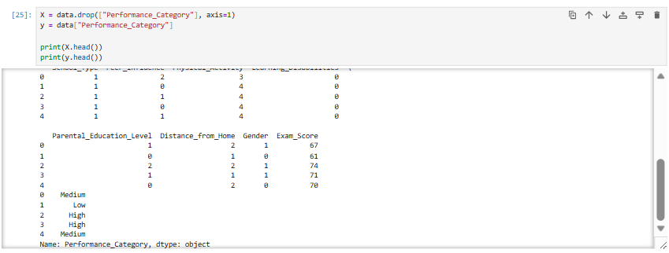
Answer
In this step, the dataset is split into training and testing sets.
The training data is used to train the classification models, while the testing data is used to evaluate their performance.
The dataset is divided using an 80% training set and a 20% testing set.
Code
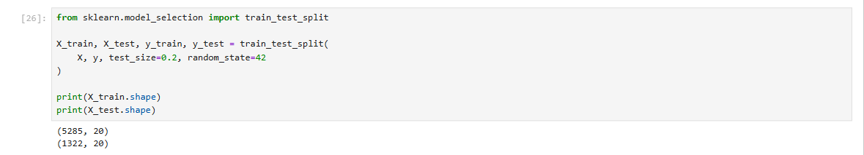

Bulding classification models (6 Points)
<< Implement and compare classification models such as Logistic Regression, K-Nearest Neighbors (KNN), Support Vector Machines (SVM), Decision Trees, and Random Forest. Evaluate model performance using metrics like accuracy, precision, recall, and F1-score. Select the best clssifier based on these metrics. Print the evaluation metrics for each model and determine the best-fit model. Your program output should be similar to the following output.>>

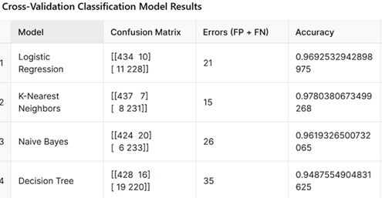
Answer

In this step, various classification models are utilized to forecast the performance class of students. The classification models that are utilized include Logistic Regression, K-Nearest Neighbors (KNN), Support Vector Machine (SVM), Decision Tree, and Random Forest. Each of these models is executed on the training dataset and then tested on the testing dataset. The performance of all models is compared using various evaluation parameters such as accuracy, precision, recall, and F1-score.
Code

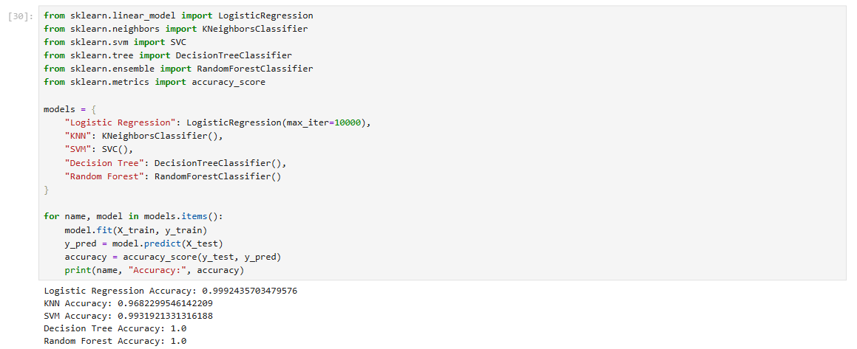
No of elements on the target variable (1 Point)

<< Find the number of elements in each category based on best-fit classifier.>>

Answer

In this step, the number of elements in each category of the target variable is determined using the best fit classifier. Here, the categories represent the various performance levels of students, such as Low, Medium, and High. Determining the number of elements in each category of the target variable gives an idea of how the data is distributed over all the classes.

Code
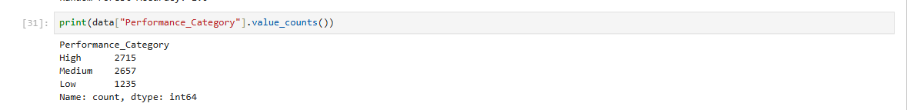
Note: Students are encouraged to apply models beyond those covered in the lecture slides to earn additional points.

Cluster Analysis (5 Points)
Building the Cluster Analysis(3 Points)
Perform K-means/ hierarchial clustering analysis on the dataset using chosen features. Determine the optimal number of clusters. Visualize the clustered data to understand how dataset are grouped.

Cluster Analysis

In order to understand the structure of the data, a cluster analysis using the chosen numerical features was performed using a K-means clustering method. The main idea of clustering is to group similar data points according to their characteristics.

To obtain the optimal number of clusters, the Elbow Method was used, which measures the sum of squares for a given number of clusters. The optimal number of clusters was obtained from the visualization.

The data was divided into several groups after applying the clustering method. The data was then visualized using a scatter plot to observe the grouping of data points. The colors in the visualization represent different clusters, which helps to identify patterns and similarities between data points.

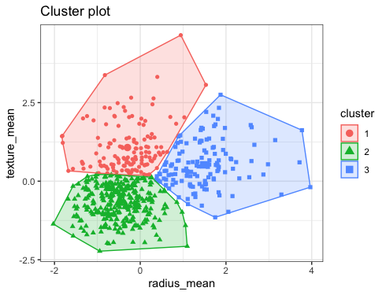

Strategy Formulation(2 Points)
Based on the clustered data, analyse each cluster and specify the strategy for each cluster.

Strategy Formulation

Based on the clustering results, three different groups were identified in the dataset. Each cluster has shown different characteristics, and therefore, we can formulate the strategy for each group.

Cluster 1 (Red):
This cluster has shown observations with relatively higher values of texture_mean. The strategy for this group of observations is to keep these observations under closer monitoring because they might indicate a different pattern compared to the rest of the observations.

Cluster 2 (Green):
This cluster has shown observations with lower values of radius_mean and texture_mean. The strategy for this group of observations is to consider these observations as the baseline because these observations indicate lower feature values compared to the rest of the observations.

Cluster 3 (Blue):
This cluster has shown observations with higher values of radius_mean. The strategy for this group of observations is to keep these observations under closer monitoring because these observations indicate different structural characteristics compared to the rest of the observations.

Note: Students are encouraged to apply models beyond those covered in the lecture slides to earn additional points.

End of Documentation.

